### 

**HOME OF THE BRAVES**

**Indian Hills Weekly Bulletin**

**December 3rd through December 7th**

|  |  |  |  |  |
| --- | --- | --- | --- | --- |
| **Monday**  **Dec. 3** | **Tuesday**  **Dec. 4** | **Wednesday**  **Dec. 5** | **Thursday**  **Dec. 6** | **Friday**  **Dec. 7** |
| **B Day** | **A Day** | **B Day** | **A Day** | **B Day** |
|  |  |  |  | **Blue & Gold Day** |

**The IHTC Present’s the Fall production of “Blithe Spirit”**

Thursday, November 29, 30 and December 1st at 7:00 p.m. in the I.H Auditorium.



**Art Club will be selling Candy- Gram next week in the Cafeteria for $1.00.**

Any questions please see Ms. Batti.

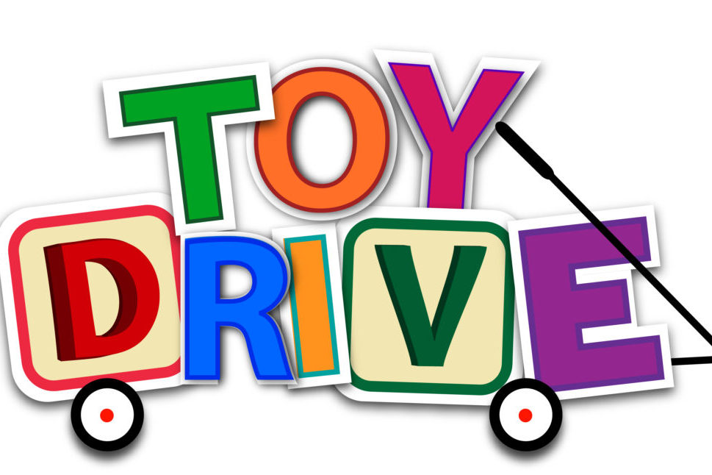

**Interact and Student Council** are hosting a toy drive. Please bring all unwrapped toys to

Room 707 before Friday, December 14th.

**Looking Ahead………**

|  |  |  |  |  |
| --- | --- | --- | --- | --- |
| **Monday**  **Dec. 10** | **Tuesday**  **Dec. 11** | **Wednesday**  **Dec. 12** | **Thursday**  **Dec. 13** | **Friday**  **Dec. 14** |
| **A Day** | **B Day** | **A Day** | **B Day** | **A Day** |
|  |  |  |  | **Blue & Gold Day** |